
QUALITY ALERT

Customer: EZ PVC - Amerilux Date: March 25, 2024
Die: 15191 / 15192 Colour: BLACK
Type of Complaint: EZ PVC - AmeriLux REJECETED

Q.A # Q.I.R # CUSTOMER NCR #

Description: Customer REJECTED black panels have the marks on top visible surface
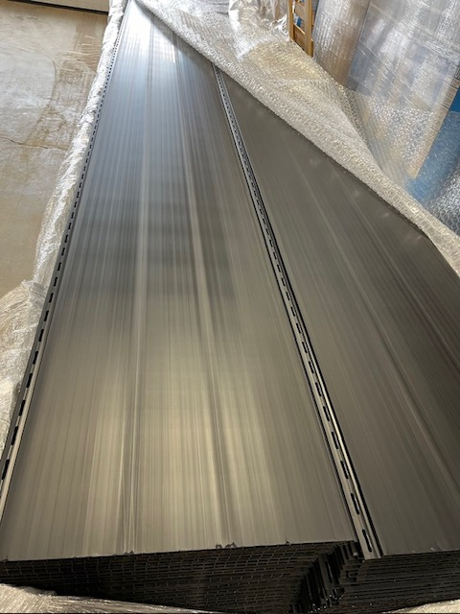

THE ABOVE MARKS ARE NOT ACCEPTABLE
BY SIGNING BELOW, YOU ACKNOWLEDGE THE PROBLEM ABOVE AND AGREE TO MONITOR THIS ISSUE IN FUTURE PRODUCTION RUNS.
DAY SHIFT |  | AFTERNOON SHIFT |  | NIGHT SHIFT
NAME | SIGNATURE | NAME | SIGNATURE | NAME | SIGNATURE

